Dear parents,
Eid Mubarak to those of you celebrating! We hope you had a lovely Easter holiday with your families. We have lots to celebrate and look forward to this term. We will be having an Eid party for Eid-ul-Adha on Wednesday 19th June 3.00-4.00pm, more details to follow nearer the time.
We are taking another staff team to Kenya to volunteer in 2 schools and a children’s home in Dagoretti and Makuyu near Nairobi at the end of May, so we are collecting for the children. Our wish list is below, last year we were overwhelmed by the generosity of our Divine Mercy families and we really appreciate your support.
Wish list for Kenya:
- Clothes like shirts and t-shirts, shorts, trousers and jumpers
- Baby clothes 0-2
- Clothes for children age 7-12
- Clothes for teenagers age 13-18
- Shoes
- Bedsheets and towels
- Bras and Underwear
- Magnifying glasses
- Sunglasses and Reading glasses
- Balloons
- Earrings
- Face paints
- Wool

This term we have a lot to celebrate, our whole school will be visiting Chester Zoo over the next few weeks, Friday 26th April Nursery, Year 2, Year 3 and Year 5 and Friday 3rd May for Reception, Year 1, Year 4 and Year 6. We are really looking forward to it and the children have been learning lots about conservation in class. One of our wonderful parents, Alexandra is coming in to do a parent pamper day on Friday 26th April and is offering discount prices for massages: £15 for a shoulder, arm and hand massage and £20 for a back massage. All welcome – please book in at the school office.

Here are the dates for your diary for April and May – please note we break up for 2 weeks on Friday 24th April and return to school on Monday 10th June 2024:

April | May
Thursday 18th April: Year 6D Mass 2.00pm | Friday 3rd May: Year 2M Class Assembly 9.00am
Friday 19th April: Year 3M Class Assembly 9.00am | Friday 3rd May: Chester Zoo Trip – Reception, Y1, Y4 and Y6
Monday 22nd April: EARTH DAY Whole school | Monday 6th May: BANK HOLIDAY SCHOOL CLOSED
Thursday 25th April: Year 6M Mass 2.00pm | Thursday 9th May: Year 5 Mass 2.00pm
Friday 26th April: Chester Zoo - Nursery, Y2, Y3 and Y5 | Friday 10th May: Year 1D Class Assembly 9.00am
Friday 26th April: Parent Pamper Day – please book in with our school office for a massage treatment with Alexandra - Shoulder, arm and hand massage £15  Back massage £20 | Mon 13th – Thursday 17th May: SATS Week Year 6
 | Tuesday 21st May: Parent Drop in
 | Thursday 23rd May: GIFT Team and Year 5M Mass 2.00pm
 | Friday 24th May: Year 1M Class Assembly 9.00am

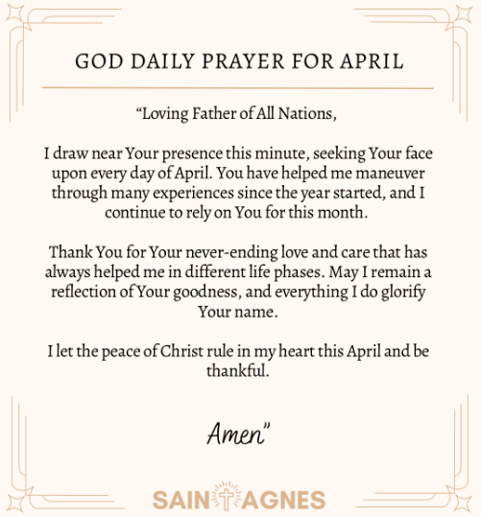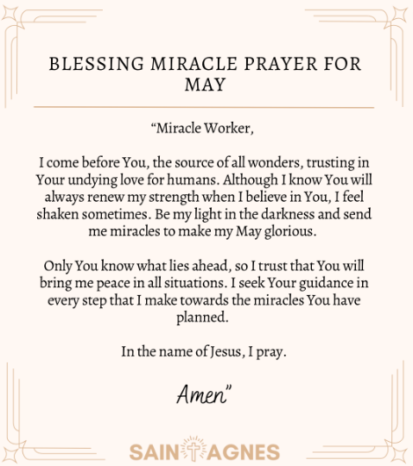
God bless
Mrs Campbell and Mr McLoughlin

